**Q13. Weather Observation Station 8**

Query the list of CITY names from STATION which have vowels (i.e., a, e, i, o, and u) as both their first and last characters. Your result cannot contain duplicates.

The STATION table is described as follows: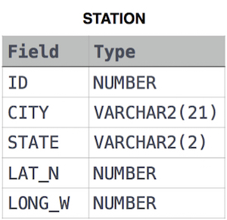

Ans.

SELECT DISTINCT(CITY)

FROM STATION WHERE

(LOWER(CITY) LIKE 'a%' or LOWER(CITY) LIKE 'e%' OR LOWER(CITY) LIKE 'i%' OR LOWER(CITY) LIKE 'o%' OR LOWER(CITY) LIKE 'u%')

AND

(LOWER(CITY) LIKE '%a' or LOWER(CITY) LIKE '%e' OR LOWER(CITY) LIKE '%i' OR

LOWER(CITY) LIKE '%o' OR LOWER(CITY) LIKE '%u')

**OR**

SELECT DISTINCT(CITY)

FROM STATION

WHERE LOWER(CITY) REGEXP '^[aeiou].*[aeiou]$'